"Lightweight Policing and Charging for Packet Networks" Demo Proposition
Bob Briscoe, Mike Rizzo, Jérôme Tassel, Kostas Damianakis, Nicolai Guba {rbriscoe| mrizzo| jtassel| kostasd| nicolai}@jungle.bt.co.uk, BT Research, BT Labs, Martlesham Heath, Ipswich, IP5 3RE, England. Tel. +44 1473 645196
We have an all Java demo of the system described in the paper. We can demonstrate dynamic tariff changes and pricing, accounting in the client domain or provider domain, payment for network transport and automated reaction to price changes using a software agent according to user spending policies. An integrated piece of software demonstrates all of the above.
The following figures are snapshots of the demo.
Fig 1: Customer Based Accounting, Billing & Payment Components
Payments
Data
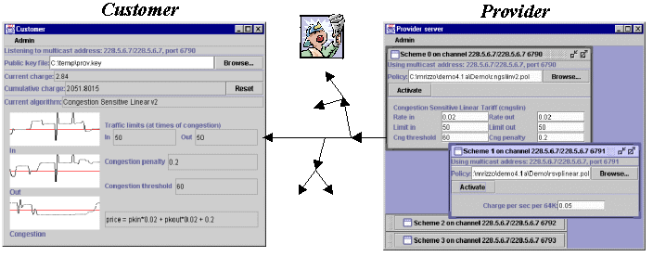
Tariffs
Fig 2: Dynamic Pricing Components
Fig 3: Client based Software Agent and QoS control components
The demo is made of 3 networked (IP Multicast enabled) PCs that represent two customers and a provider. A typical scenario for the demo is to first demonstrate charging for straight network usage (i.e: bytes) and then to introduce a new tariff to charge for QoS in an RSVP context (by multicasting the new tariff algorithm to the end devices live). The end user GUI can then be used to demonstrate the change in cost to the user and the QoS adaptation by the software agent on the behalf of the user to match the user constraints. E-Payments from the user account to the provider are also made visible. The flexibility of the system to introduce or modify tariffing algorithms and the control of the user located accounting system are also demonstrated.

